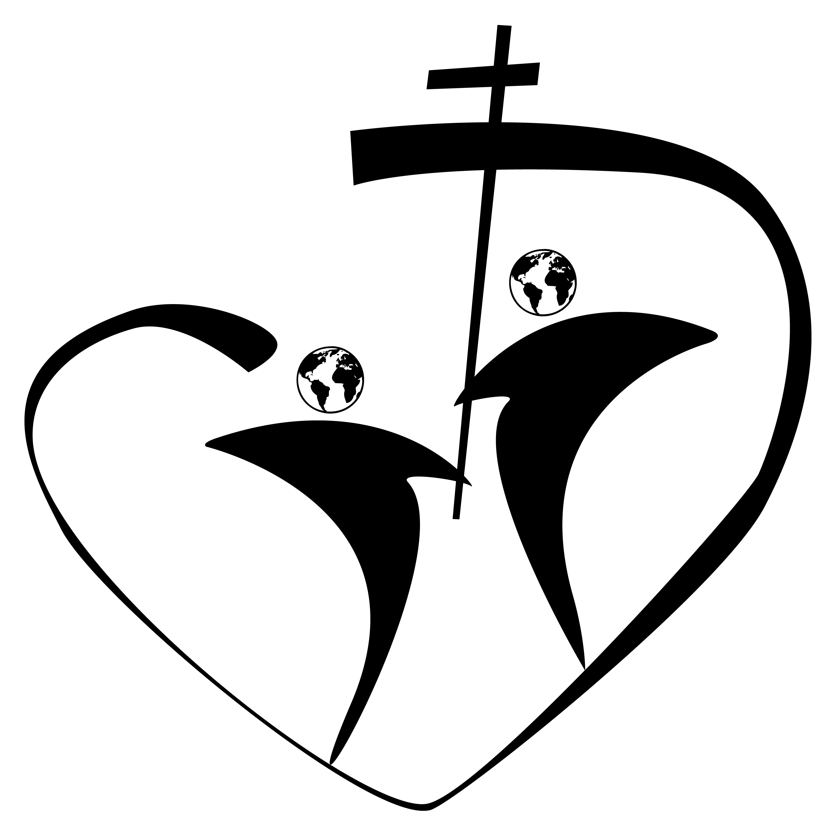
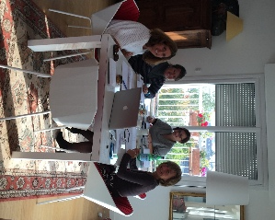
Written by Sabine du Vignaux, exchange coordinator

FOH: Faces of the Heart. It was an idea first launched by Luciana Jeler, a French teacher from Bloomfield Hills, Michigan. It was approved by many exchange coordinators, but signed by only a few. As for me, I responded immediately because I had already had the same idea in mind, and with the support of Christophe Corda, Headmaster of La Perverie, I felt reassured. Luciana came to France in October 2015. We had everything we needed
Abigail WalhGenon, Marie-Béatrice Jarny, LucianaJeler, Sabine du Vignaux
to make the adventure work. So forward we went!

Everything was ready, the flyer was sent out on November 13th. A few hours later, the terrorist attack in France jeopardized the project.

So at first FOH was stressful. We didn’t have enough people signing up and at the same time, we needed to confirm our bookings…
We supported each other, we continued to believe in our project, we had alreadyinvested too much to turn back, we had already signed contracts with various companies (for the buses, activities, hotels...)
The first meeting was in Washington in February.
At the end of March, we could finally breathe easily, we didn’t have the number of people planned, but it was a start.

FOH would be in 2016
27 teenagers between the ages of 15-18 (4 boys, 23 girls) and 6 adults
11 nationalities 21 different schools
The camp’s theme would be:
“How do our Sacred Heart valuestranslate into choices and actions when it comes to the use of the world’s resourcesto feed the planet?”

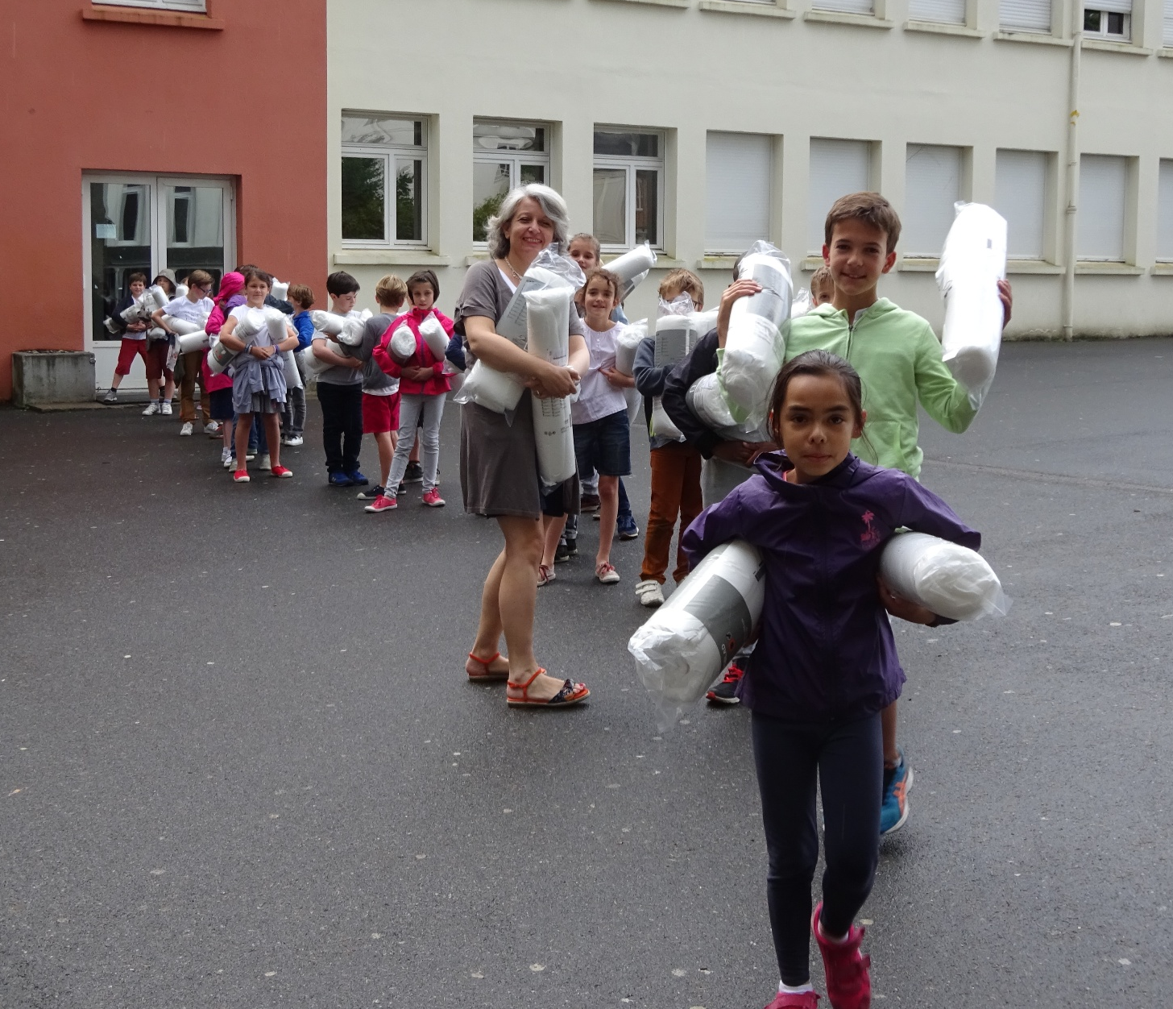
Starting in April, we asked the students to prepare a presentation of their school and to introduce themselves briefly using the Internet. I was impressed by Google drive, Google sheets, Google docs, Google slides, and conference calls bringing together Michigan, France, New Jersey, and Missouri. It was amazing! We worked together on the same document thousands of miles away from each other.

The program and the logistics were put in place. We were looking forward to starting. At La Perverie, teachers, students, and parents, the choirmaster, the accountants, the maintenance, cleaning, and cooking staff, the principal, all were helping; there was so much to do!!
Les élèves de Madame Lepoutre montent à l’internat, couette et oreillers

The third of July was the DAY - the big day we had all been waiting for. Everyone was there… well almost everyone, four people were missing. One adult was held back in London, another adult was waiting in Paris for two girls who were stuck in Iceland!
On the fourth of July the priest John Suakor, father of the Society of African Missions opened the camp with an International Mass celebrated in English. Madeleine-Sophie Barat was at the heart of the celebration.

NANTES

For 8 days in Nantes the teens had a schedule filled with a variety of different activities with time for thinking, learning and relaxing.

Thinking
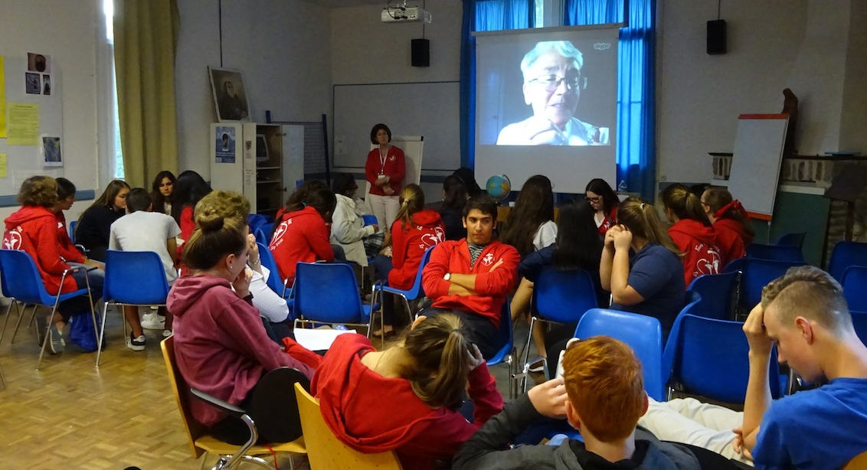
Via Skype, Sister Diane Roche, rscj, spoke of the integrity of Creation and Dan Di Leo from the Catholic Climate Covenant in Washington, D.C. referred to Pope Francis’ encyclical, Laudato Si and talked about consumer behaviour through the prism of Faith.
Discussion time allowed the teenagers to share their thoughts and explore cultural diversity.

Praying
At the end of the day, before going back to their rooms, there was time for prayer. All of the participants chose to go to the Saturday evening Mass in French at Saint Nicolas.

Learning
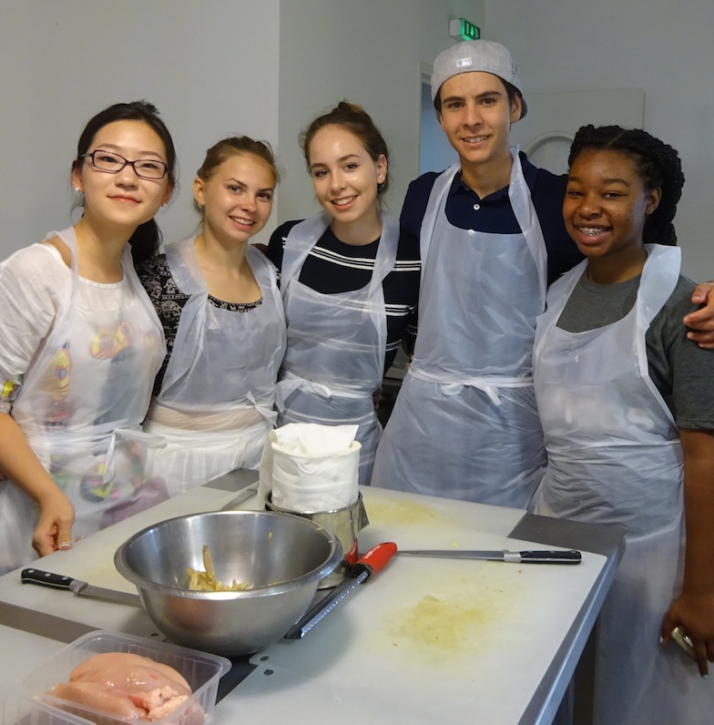
Professionals came to talk to the group: Compostri and la Tricyclerie, two young businesses that campaign for recycling food stuffs. We visited an AMAP (an association for maintaining old-style, small-scale agriculture).
A nutritionist talked to us about how food behaviour has changed over time and about the dangers of excessive sugar consumption.
A history teacher gave a presentation on “Feeding Humanity” and went back in time to antique and royal cuisine.
The group learned about French cuisine through a cooking lesson at a chefs’ workshop.

Relaxing
Paddling to the rhythm of drums beating the melody of La Promesse du Sacré-Cœur in a magnificent Dragon boat, searching for the answer to riddles aboard a canoe, on a scavenger hunt through the city streets of Nantes, buying lunch at the Talensac market, discovering the Machines de l’Ile, the botanical gardens, dining at La Cigale, spending a Sunday with a French family and watching the Euro Soccer Cup final, these are a few of the ways the teenagers relaxed, laughed, rested and did their laundry.

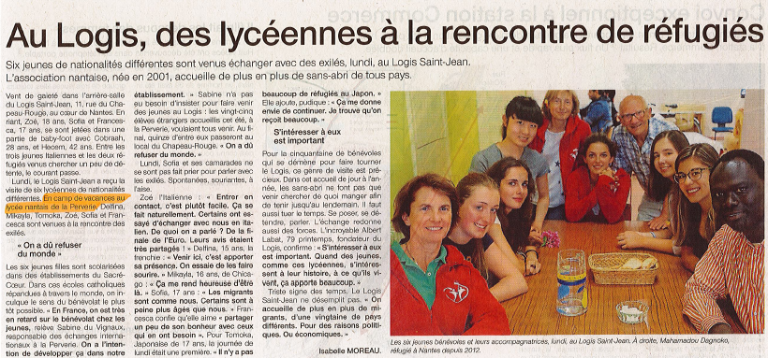
Giving
The teenagers showed us their generosity. They all wanted to go to the Logis Saint Jean an outreach center for refugees. During a meal they went to speak to and play with the young men in difficult situations.

Being amazed
They had never imagined or seen such a thing. LE PUY DU FOU and the CINESCENIE will undoubtedly be part of their best memories of their stay in Nantes, at least the most memorable. I’ll say no more: either you have already been or you must go.

The time in Nantes ended with a big barbecue and Nicole Cortes’s fall – she spent the rest of the camp on crutches with a splint!

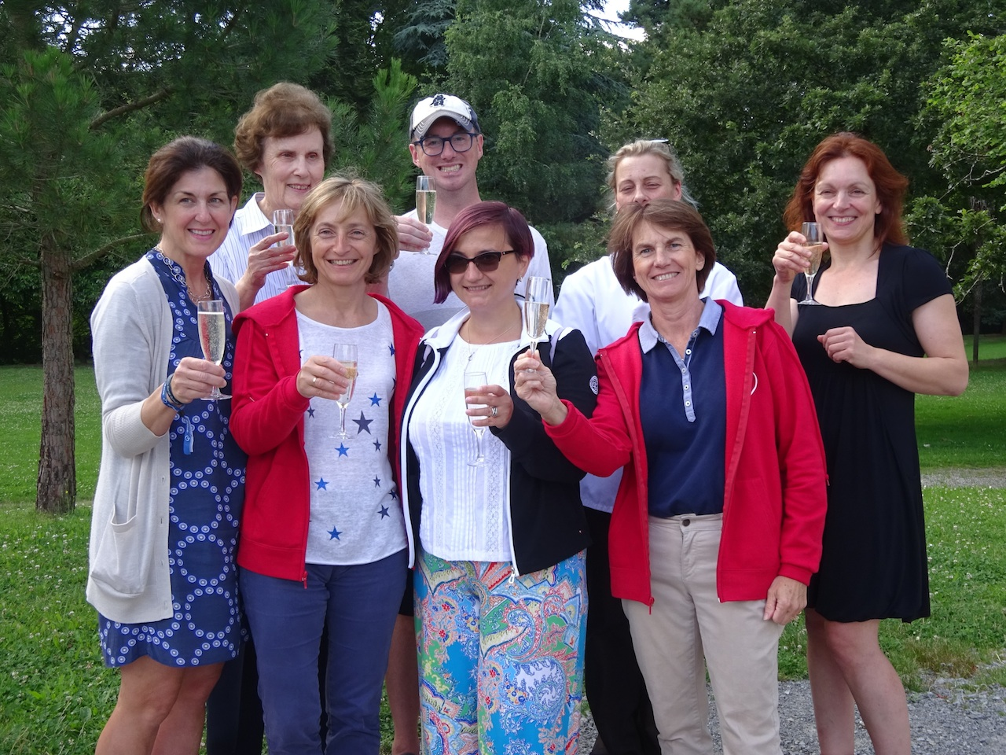

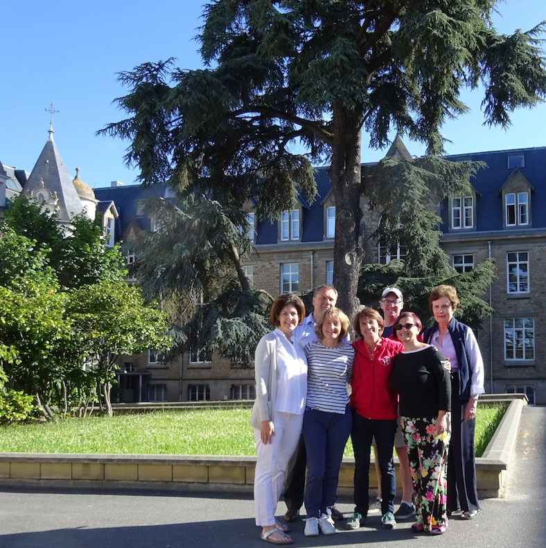
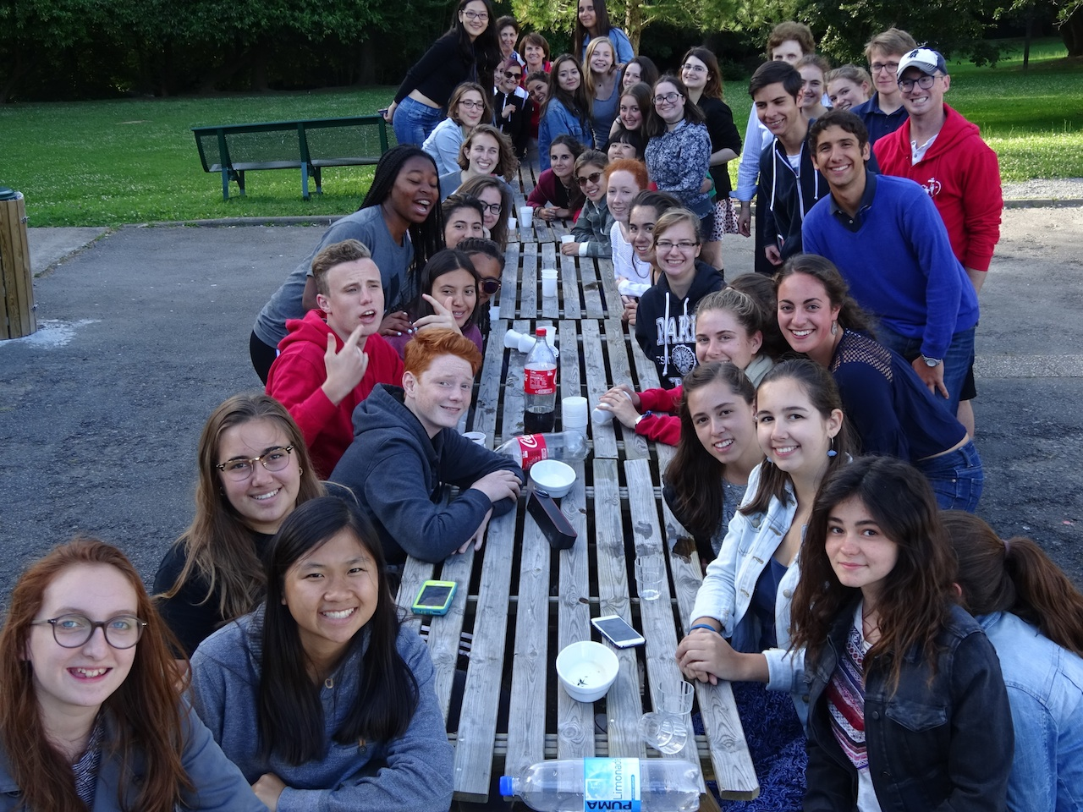
JOIGNY
Visiting Joigny was the cornerstone of our trip. The nuns/sisters at the Barat center welcomed us warmly and with great kindness. In the peacefulness of the setting, the teenagers discovered our founder's youth. Walks in the vineyards, visiting her house and her town brought us closer to Madeleine-Sophie. How could we not thank her, it was thanks to her that we had come together, she was what united us. The place was conducive to reflection and prayer.
PARIS
We left the serenity of Joigny for another important place: Paris.
First, following Madeleine-Sophie's footsteps, with Sister Amélie Jarousse as our guide, we visited The Rodin Museum, which had been the house of the Sacred Heart for 84 years, Saint François-Xavier Church, Rue de la Poste, Rue Mouffetard and the Vasse Hotel.
Then following the unescapable steps as tourists we visited Montmartre, the Basilica and La Place du Tertre. We went shopping, took a boat ride on the Seine on the famous « bateaux-mouches » and relaxed in the booths of the very typical French brasserie, Bouillon Chartier.
THE END – ROISSY
At the break of dawn on July 17th the first taxis arrived in front of the youth hostel to take the first teenagers leaving to the airport. The tears reassured us – friendships and bonds had been created. The morning was filled with a series of similar transfers; each teen was taken to their gate at the airport. Not a single plane was delayed! We were happy, relieved, tired, but also sad to leave those who had been our children for the past two weeks.

EPILOGUE
Luciana Jeler can be proud to have created this project. Alone, she wouldn't have been able to do it but she was the initiator and the motor of the project from September 2015 to July 2016. From the simple idea of a summer camp, this project became the first international youth gathering of the Sacred Heart.
We discovered engaged, intelligent, knowledgeable youths who were able to have fun but also to think. They are the future of the Sacred Heart, they love their founder and their schools and they believe in the values transmitted by our institutions. At their level they represent our network’s internationality.
The headmasters, the religious community and the alumni all have their international congress, why not the students? There are youth delegates at the UN, there is the European Youth Parliament, why not an international youth assembly within the Sacred Heart?
Where do we go from here?
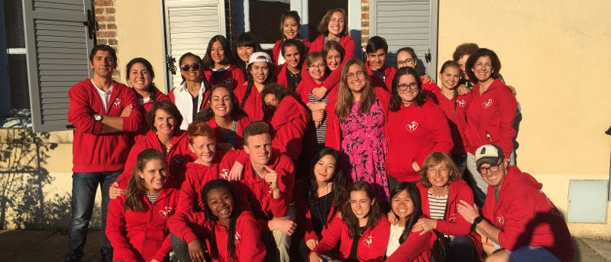
WHERE ?

HOW ?

WHO ?

WHEN ?

